|  |
| --- |
| **School of Information Technology**  **Diploma in Information Security**  **IT2529**  **InfoSecurity Project**  **AY2012/2013 S1**  **LaoCheng**  **Project Report**  MODULE GROUP: **DIS1102**  PROJECT TEAM: **3**  **Alvin Lee Yong Teck (LEADER)**  **Chong Siew Yuet**  **Tan Yong Chin Amos**  **Toh Jian Hao**  **Yeo Wei Chen** |

Table of Contents

**Project Proposal** 3

Introduction 3

Business Case 3

Business Functions: 4

Security Functions: 6

Architecture Diagram 8

Resource 8

**Project Plan** 9

Team Organization 9

Task Allocation 9

Schedule 10

Gantt Chart 11

**Requirement Specifications** 12

Use Case Diagram 12

Use Case Description 13

Domain Class Diagram 29

**Design Specifications** 30

Design Considerations 30

Design Class Diagram 30

Sequence Diagram 33

**Test Plan** 39

Test Setup 39

Test Procedures 39

Test Cases 39

**Conclusion** 48

**Appendices** 49

# Project Proposal

## Introduction

Our project is an online middle men system for buying and selling of wares and currencies online. It’s named the LaoCheng+; provide security for Users engaging in activities involving the movement of money. It provides various measures to secure the client, not just from malicious characters who threaten our client’s personal data and finances but also from a more over look threats-the person you are dealing with.

In E-Commerce it is possible for either buyer or seller to be cheated as they do not know who they are dealing with and therefore he or she can easily disappear with the client’s money. A solution is to have another person to manage dealings between buyer and seller, making sure a buyer and seller get their end of the deal. LaoCheng+ serves to be that third person. As a fully automated system it will treat all its users in a fair and unbiased manner. As LaoCheng+ is trusted by all affiliated parties you can easily use LaoCheng+ to be the financial middle-men without argument when trading with other LaoCheng+ users and know that they can be trusted.

## Business Case

LaoCheng+ aims to provide a safe avenue for clients when they perform any sort of online activity involving money. Such as paying for products online, selling products online and trading in the Foreign exchange market. The security features we provide to protect our client is network security; encryption algorithms to encrypt sensitive information; checking if integrity of client’s request for services has been compromised; and authenticating that our clients are really who they say they are.

Through these measures we ensure that our client’s personal information is not compromised by an unauthorized intruder. Our network security and encryption algorithm prevents the stealing of information during online transactions. Integrity checking makes sure that our client’s requests do not get modified before they reach the server. Authenticating ensures that only our client can decide whatever he or she wants to do with their money and personal details and no one else.

Our security measures do not just guard against outside threats; LaoCheng+ also has measures to protect our client from within the team. Built in access control ensures that all authorized users actions regarding our client’s data is controlled and that not one individual has control over the whole system. Furthermore, in the event a third party needs to look into our system for various reasons we can ensure that they will only have enough access to do their duty and no more.

LaoCheng+ does not only secure our clients data and money, it also provide ways to clear up potential disputes between buyer and seller. Whenever a client purchases products online, money from a client’s account will not be given to the seller first, only when the client receives the goods will the he or she be given the money. Once the client has confirmed he or she has received the goods, they will not be able to stop LaoCheng+ from transferring the money; Ensuring that no one-buyer or seller-can be cheated so easily when using LaoCheng+ online activities.

Furthermore when confirming purchase we provide non-repudiation to prove that the client bought and gotten hold of the goods and that the seller has received the money. This ensures that they cannot deny purchase or sale later on, dissolving any future legal issues. Such as a buyers complaining of paying the money but not receiving the goods or sellers claiming that they received not payment.

LaoCheng+ also gives attractive offers to our clients when they use our services. When using any of LaoCheng+ services one can get a number of tokens. Once sufficient amount of tokens has been amassed, tokens can be traded for bonuses, special gifts, discounts and many more. Throughout the year, we will be giving out special coupons which can be used in LaoCheng+ to get special offers and promotions.

In LaoCheng+ we always give special care and attention to the needs of our clients. We provide safe channels for our clients to deal with money online with no worries. Buyers can enjoy surfing and browsing through products in our e-commerce portal, while sellers can just simply wait and relax for the money to come into their accounts.

## Business Functions

LaoCheng+ provides unique advantages and exclusive services that only LaoCheng+ clients are able to enjoy-we secure deals between buyer and seller to ensure that both get what they agreed upon, exclusive offers to show our appreciation for people who use LaoCheng+. In addition Foreign Exchange Trading can be done through our system.

The various features we offer support our clients from various angles; Business and Consumer. They are all listed below for viewing.

Business

1. Product System
2. Currency Updating System

Consumer

1. Credit/Voucher System
2. Guarantee System (QR reader on Android)

When our client does business online they demand much from the system they are using to aid them. Aside from security features, they want features to help make trading easier, give them up to date information to work on as well as make all actions they need done quick and efficient. LaoCheng+ provides all that is needed for a client to do their business online.

The system provides various avenues for online shopping and sale of goods over the web. When you create an LaoCheng+ account, Users can almost immediately start shopping or selling online. All they need to do is transfer money into their LaoCheng+ account and/or show off their wares to other potential buyers. The system eases the process of shopping online, User’s merely have to pick the product they want and let the system take care of payment, then wait for their purchase to be delivered. Sellers just have to let LaoCheng+ deal with delivering the goods to the buyer and wait for the money to come to them.

Foreign Exchange Trading can be done while using the services and security of LaoCheng+. Real-time currency prices are given to the user through the use of AJAX auto refreshing, so users are always viewing up to date information about currency prices. The system aims to allow Users to buy and sell currency with a single click, nothing more is needed and there is no delay in the actions.

Despite all that there are some clients who don’t want to business and rather just shop. Like the other group that wants to do business they want support as well when they are enjoying themselves. LaoCheng+ gives the necessary features to let these clients get the best possible deals as well as guarantee they will get what they paid for.

Aside from just offering support for E-Commerce, LaoCheng+ provides other features to improve users experience when trading online. Whenever products are purchased through LaoCheng+, the user can get a number of tokens based on various conditions-such as purchasing more than a hundred dollar worth of goods. When amassed to a sufficient amount they can be exchanged for bonuses and discounts-for example using tokens to pay for products or getting special rates for certain services. Users can choose to give any products they obtain through the system to another User, as a form of a gift payment or otherwise.

When the clients first purchase their product, they first must put their money in a ‘safety deposit box’ held on by LaoCheng+, now the money is untouchable by buyer and seller, thus the latter must deliver the goods in order to be paid. The goods will have to be scanned by the client with a QR reader in their Android-given to them when they register for an LaoCheng+ account-when they receive it. This checks that they were given the correct merchandise and provide electronic evidence of the purchase so that they cannot deny it later on. Only when the goods has been scanned and confirmed to be the buyer’s choice will the seller be given the money.

## Security Functions

LaoCheng+ provides security features to guard the personal data and money of our clients. The security features can be divided into various categories based on what they aspect of security are they protecting. These categories are Authentication, Confidentiality and Integrity, Availability and Internal Security. Below are lists of features under each category.

Authentication

1. Two-Factor Authentication (2FA)
2. Secure Socket Layer

Confidentiality and Integrity

1. Database Encryption
2. Password Hashing

Availability

1. Captcha System

Internal Security

1. User Access Control

Authentication is to find out and confirm the identity of a person or entity. When LaoCheng+ receives a request for allowing a user access to their account or to perform a financial transaction, it first identifies the one who requested it and confirm it is the user before any other action can take place. Otherwise it can be fooled to giving an unauthorized third party personal data or control regarding the client’s finances. Before the user is able to access their LaoCheng+ account, they first must identify themselves through Two-Factor Authentication (2FA), in addition to the entering of a username and password, the user must also type in a PIN number sent to them through SMS, before they can use their LaoCheng+ account. Secure Socket Layer (SSL) protocol is used to identify people and organization before sensitive data about clients are sent to them, assuring that only authorized people get the data.

Confidentiality refers to only allowing authorized parties to access the data and Integrity takes this step further by also only allowing the same parties to modify that data. The client’s personal and financial information are at risk of being stolen by various malicious characters due to their value. All data in our data base I encrypted with various secure formulas, even if we are compromised the attacker cannot gain access to any of our client’s data and compromise them. Before passwords are sent to the server to be verified LaoCheng+ performs a complex and irreversible mathematical process to the password in order to change it to a hash. This prevents people from being able to read it one the process is done.

Availability is reference to how the system should be available to the user whenever they need it. LaoCheng+ protects itself from attacks that could cause it to crash, such Denial of Service (DoS) attacks, which causes the systems resource to be used up to the point the it will crash due to the strain. Captcha tests are one measure to protect the computer from such attacks. The test ensures that it is a human attempting to login and not a computer attempting to login, since most of these attacks are caused by an automated programs this can reduce the number of attacks on the system.

Internal Security refers to securing the inside of the system. This is achieved by controlling access to various parts of the system. Administrator will have tokens to give them their ability to access parts of the LaoCheng+ system and also perform any actions concerning those parts. For example, an Administrator may only be given tokens to access the Client Control Panel but is not given any tokens to ban any of them but is given tokens to ban their ability to transfer funds. The Access Control system can give and take privileges at any time from any Administrator regardless of rank. Thus if an Admin is suspected of misusing his or her power they can have their rights revoked.

Furthermore, a temporary Administrator account can be set up for third parties to access the system for various reasons; these temporary Administrative Accounts are similar to an Administrator except that they will become inactive once their specified term has expired.

Finally, all actions if Administrators are recorded in a log with the date and time of when they occurred. This can be used to see if the Administrator is performing any suspicious activities, like attempting to transfer funds from one user account to his or hers.

### Architecture Diagram

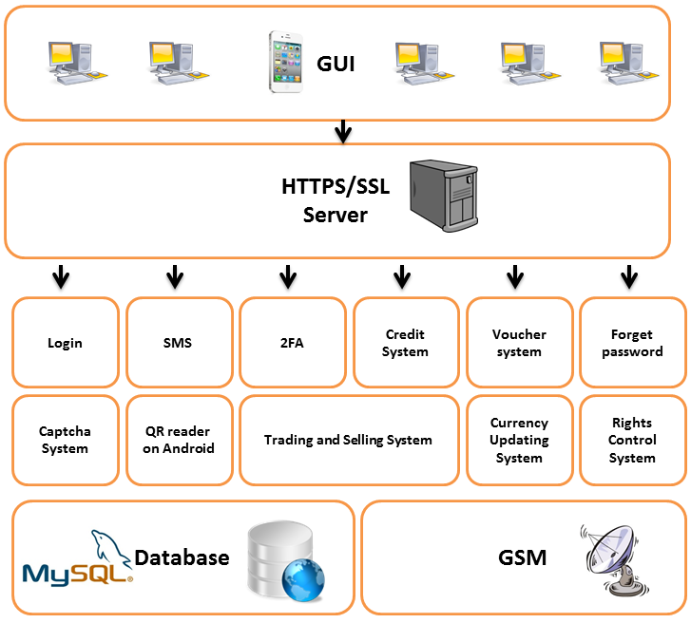

### Resource

The following software is needed for the development of our project:

* Microsoft Visual Studio 2010 Ultimate
* Eclipse IDE for Java EE Developers
* JDK 7
* Microsoft Office 2010
* NetBeans IDE 7.1.2

The following hardware is needed for the development of our project:

* Laptops
* Server
* Smart Phone
* GSM Modem

Other facilities that are needed for the development of our project:

* Computer Labs
* Meeting/Discussion Rooms
* Library

# Project Plan

## Team Organization

**Module Group:** IT2529- DIS1102

**Team Name:** LaoCheng

**Team No:** 3

**Team Leader:** Alvin Lee

|  |  |  |  |  |
| --- | --- | --- | --- | --- |
| **S/N** | **Name** | **Admin No** | **Handphone No** | **Email Address** |
| 1* | Alvin Lee Yong Teck | 113340E | 83664422 | [113340E@mymail.nyp.edu.sg](mailto:113340E@mymail.nyp.edu.sg) |
| 2 | Chong Siew Yuet | 114905L | 96482229 | [114905L@mymail.nyp.edu.sg](mailto:114905L@mymail.nyp.edu.sg) |
| 3 | Tan Yong Chin Amos | 114853Y | 91182989 | [114853Y@mymail.nyp.edu.sg](mailto:114853Y@mymail.nyp.edu.sg) |
| 4 | Toh Jian Hao | 111413S | 91289752 | [111413S@mymail.nyp.edu.sg](mailto:111413S@mymail.nyp.edu.sg) |
| 5 | Yeo Wei Chen | 113159H | 91883624 | [113159H@mymail.nyp.edu.sg](mailto:113159H@mymail.nyp.edu.sg) |

*denotes the team leader

## Task Allocation

|  |  |  |  |  |  |  |
| --- | --- | --- | --- | --- | --- | --- |
| **S/N** | **Task** | **Alvin Lee** | **Amos Tan** | **Wei Chen** | **Siew Yuet** | **Jian Hao** |
| 1 | Currency Exchange System | ✓ |  |  |  |  |
| 2 | Shopping Cart |  |  |  | ✓ |  |
| 3 | Quality Service Management |  | ✓ |  |  |  |
| 4 |  |  |  |  |  |  |
| 5 | Access Control |  |  |  |  | ✓ |
| 6 | Manage Account Interface |  |  |  |  | ✓ |
| 7 | Login System |  |  | ✓ |  |  |
| 8 | 9-dot Security Pin | ✓ |  |  |  |  |
| 9 | Captcha |  |  |  | ✓ |  |
| 10 | Two-Factor Authentication (2FA) |  | ✓ |  |  |  |
| 11 | Salt Hashing |  |  | ✓ |  |  |
| 12 | Secure Socket Layer (SSL) |  |  |  |  | ✓ |
| 13 |  |  |  |  |  |  |

## Schedule

Our project phases, deliverables and schedule are as follows:

|  |  |  |
| --- | --- | --- |
| **Phases/Deliverables** | **Week** | **Deadlines of Deliverables** |
| **Project Briefing** | **1** | **N.A.** |
| **Team Organization Form** | **2** | **27 Apr 2012** |
| **Project Inception**   * Project Proposal * Project Plan (PP) | **4** | **11May 2012** |
| **Project Requirements**   * Requirements Specification (RS) | **6** | **25 May 2012** |
| **Project Design**   * Design Specification (DS) * Prototype Demo | **8** | **8 Jun 2012** |
| **Individual Roles 1**   * Credit/Voucher System **Siew Yuet** * Product System **Amos** * Website UI Design **Wei Chen** * User Control Panel **Jian Hao** * Login & Register **Alvin** | **11** | **28 Jun 2012** |
| **Project Implementation**   * Preliminary Implementation Demo * Test Plan (TP) * Poster | **12** | **6 Jul 2012** |
| **Individual Roles 2**   * Currency Updating System **Alvin** * Rights Control System **Jian** **Hao** * Password Hashing **Siew** **Yuet** | **14** | **20 Jul 2012** |
| **Individual Roles 2 (cont.)**   * Two-Factor Authentication (2FA) **Alvin** * QR reader on Android **Amos** * Captcha System **Wei** **Chen** * HTTPS/SSL **Jian** **Hao** * Database Encryption **Siew** **Yuet** | **16** | **3 Aug 2012** |
| **Project Evaluation**   * Poster * PowerPoint Slides * Project Demo * Final Project Report * Software | **17** | **TBD** |

**Legend**  
*N.A. – Not Applicable  
*TBD – To be Determined

## Gantt Chart – Alvin Lee (Red), Siew Yuet (Green), Amos (Yellow), Wei Chen (Orange), Jian Hao (Purple)



# Requirement Specifications

## Use Case DiagramC:\Users\Vin\Desktop\Shortcuts for Rocketdock\School Work\Y2S1\IT2529 - InfoSecurity Project\LaoCheng\Week 6 - Requirement Specifications\(LaoCheng) Use Case Diagram v2.jpg

## Use Case Description

**Currency Trading – Alvin**

|  |  |
| --- | --- |
| **Use Case Name:** | **Currency Trading (Converter & Rates)** |
| **Brief Description:** | Allow Users and Merchants to convert money and view the rates between two currencies selected from multiple currencies |
| **Actors:** | Users, Merchants |
| **Pre-Conditions:** | Guest must login as User or Merchant |
| **Post-Conditions:** | - |
| **Basic Flow:** | 1. On the ‘Currency Trading’ page, it shows a converter and the rates of the currency 2. In the converter, Users or Merchants will select between two currency types (i.e. SGD – Singapore Dollar and USD – United State Dollar) 3. Enter an amount of money 4. Click on the ‘Convert’ button and the conversion occurs 5. It shows the amount of money that was converted from one currency to another, and vice versa (i.e. 1000 SGD = 750 USD; 1000 USD = 1250 SGD) 6. It will also shows the currency rates of the two currencies during that exchange 7. In the rates, Users or Merchants will select between two currencies types (i.e. SGD – Singapore Dollar and USD – United State Dollar) 8. Click on the ‘View Rates’ button to view the rates of the two currencies (This is more convenient than the converter as there is not a need to include any amount of money to view the rates) |
| **Alternate Flow:** | - |

|  |  |
| --- | --- |
| **Use Case Name:** | **Currency Trading (Exchange Currency)** |
| **Brief Description:** | Allow Users and Merchants to exchange the currency between two currencies selected from multiple currencies |
| **Actors:** | Users, Merchants |
| **Pre-Conditions:** | Guest must login as User or Merchant |
| **Post-Conditions:** | Money was exchanged between the two currencies |
| **Basic Flow:** | 1. On the ‘Currency Trading’ page, it shows a converter and the rates of the currency 2. Conversion Process [Refer to Use Case Name: Currency Trading (Converter & Rates), points (2) to (6)] 3. After conversion, click on the ‘Exchange Currency’ button 4. It will show the balance before and after the conversion between the two currencies 5. After confirmation, click on the ‘Confirm Exchange’ button |
| **Alternate Flow:** | 1. If there's insufficient fund in their account, it will prompt the user to deposit money into their account |

**Manage Profiles – Alvin**

|  |  |
| --- | --- |
| **Use Case Name:** | **Manage Profiles (View/Edit particulars)** |
| **Brief Description:** | Allow Users and Merchants to view & edit their own particulars |
| **Actors:** | Users, Merchants |
| **Pre-Conditions:** | Guest must login as User or Merchant |
| **Post-Conditions:** | - |
| **Basic Flow:** | 1. On the ‘Manage Profiles’ page, it shows all the personal particulars of the individuals 2. Click on the ‘Edit Profile’ button 3. Edit any necessary amendments 4. Click on the ‘Save Changes’ button |
| **Alternate Flow:** | - |

|  |  |
| --- | --- |
| **Use Case Name:** | **Manage Profiles (Deposit money from bank)** |
| **Brief Description:** | Allow Users and Merchants to transfer the money from their bank account, and deposit it into their account in our system |
| **Actors:** | Users, Merchants, Service Provider (Bank) |
| **Pre-Conditions:** | Guest must login as User or Merchant; Must have a bank account |
| **Post-Conditions:** | Money will be deducted from bank account and deposited into account in our system |
| **Basic Flow:** | 1. On the ‘Manage Profiles’ page, click on the ‘Deposit’ button 2. Fill in personal information  * Email address * Bank account number * Amount of money * Password * Security Answer * Captcha [Refer to Use Case Name: Captcha, points (1) to (3)]  1. Click on the ‘Confirm Deposit’ button 2. Request will be sent to the Service Provider (Bank) and transaction will be done within one working day |
| **Alternate Flow:** | 1. If there are insufficient money in the bank, it will prompt the user for insufficient money, and transaction was not successful |

|  |  |
| --- | --- |
| **Use Case Name:** | **Manage Profiles (Transfer money to Bank)** |
| **Brief Description:** | Allow Users and Merchants to transfer the money from their account in our system, and deposit it into their bank account |
| **Actors:** | Users, Merchants, Service Provider (Bank) |
| **Pre-Conditions:** | Guest must login as User or Merchant; Must have a bank account |
| **Post-Conditions:** | Money will be deducted from their account in our system and deposited into bank account |
| **Basic Flow:** | 1. On the ‘Manage Profiles’ page, click on the ‘Transfer to Bank’ button 2. Fill in personal information  * Email address * Bank account number * Amount of money * Password * Security Answer * Captcha [Refer to Use Case Name: Captcha, points (1) to (3)]  1. Click on the ‘Confirm Transfer’ button 2. Request will be sent to the Service Provider (Bank) and transaction will be done within one working day |
| **Alternate Flow:** | 1. If there are insufficient money in their account in our system, it will prompt the user for insufficient money, and transaction was not successful |

**Login – Wei Chen**

|  |  |
| --- | --- |
| **Use Case Name:** | **Login (2FA)** |
| **Brief Description:** | Login as an(a) user, merchants or admin to access respective accessible features |
| **Actors:** | Guests |
| **Pre-Conditions:** | - |
| **Post-Conditions:** | - |
| **Basic Flow:** | 1. From home page, click on ‘Login’ 2. The login page is secured (https) 3. Enter email and password 4. Proceed to login 5. 2FA will then be activated and a SMS will be sent to the phone number linked to this account by the SMS Service Provider 6. The SMS will contain a onetime password that must be entered on the website before the guest can login 7. Guest enter the onetime password 8. The system will then check whether is it an(a) user, merchants or admin account 9. Guest is now successfully logged in with respective access control |
| **Alternate Flow:** | - |

|  |  |
| --- | --- |
| **Use Case Name:** | **Login (Forgot Password)** |
| **Brief Description:** | To retrieve forgotten password for respective username |
| **Actors:** | Guests |
| **Pre-Conditions:** | Registed user |
| **Post-Conditions:** | Password is changed and sent to user |
| **Basic Flow:** | 1. On the login page, click on ‘Forgot Password?’ 2. Enter email 3. Given the security question of the email during registration, enter the security answer 4. Validation of security answer 5. Guest will then be allow to enter their new password 6. Validation check for password 7. Password Changed 8. Guest can now proceed to login with their new password |
| **Alternate Flow:** | - |

|  |  |
| --- | --- |
| **Use Case Name:** | **Login (Remember Me)** |
| **Brief Description:** | To provide convenience for guest to have their email remembered |
| **Actors:** | Guests |
| **Pre-Conditions:** | - |
| **Post-Conditions:** | - |
| **Basic Flow:** | 1. From home page, click on ‘Login’ 2. Check the ‘Remember Me’ checkbox 3. Login Process [Refer to Use Case Name: Login (2FA), points (3) to (9)] 4. Upon successfully login, the email will be remembered and will be auto filled the next time the page is entered from the same computer |
| **Alternate Flow:** | - |

**Register – Wei Chen**

|  |  |
| --- | --- |
| **Use Case Name:** | **Register (Enter personal information)** |
| **Brief Description:** | To create an user account |
| **Actors:** | Guests |
| **Pre-Conditions:** | - |
| **Post-Conditions:** | Account created |
| **Basic Flow:** | 1. From the home page, click ‘Register’ 2. The register page is secured (https) 3. Fill in personal information  * Email address (Checking for availability of email) * Password (Validation Check) * Confirm password (Validation Check) * Name * Birthdate * Gender * Country * Address * Phone number * Security Question * Security Answer * Captcha [Refer to Use Case Name: Captcha, points (1) to (3)]  1. Agree to terms and conditions 2. Validation check for all fields from points (3) to (5) 3. Create account 4. Receive email 5. Activate account from email 6. Guest can now proceed to login |
| **Alternate Flow:** | - |

**Shopping – Siew Yuet**

|  |  |
| --- | --- |
| **Use Case Name:** | **Shopping (View Product)** |
| **Brief Description:** | Allow Users, Guests and Merchants to view the available product and its details |
| **Actors:** | Guests, Users, Merchants |
| **Pre-Conditions:** | - |
| **Post-Conditions:** | - |
| **Basic Flow:** | 1. Display category 2. User select category 3. Retrieve product from database 4. Display out necessary information of the product (i.e. Product name, cost etc.) |
| **Alternate Flow:** | - |

|  |  |
| --- | --- |
| **Use Case Name:** | **Shopping (Search Product)** |
| **Brief Description:** | Allow Users, Guests and Merchants to search for the available product |
| **Actors:** | Guests, Users, Merchants |
| **Pre-Conditions:** | - |
| **Post-Conditions:** | - |
| **Basic Flow:** | 1. Enter the product name in the textbox 2. Select the search base on the category for the product 3. Retrieve from database 4. Display the result |
| **Alternate Flow:** | 1. If item not found, search result is 0. Can choose to search again or go to other pages |

|  |  |
| --- | --- |
| **Use Case Name:** | **Shopping (Add to cart)** |
| **Brief Description:** | Allow Users and Merchants to add product to their own individual cart |
| **Actors:** | Users, Merchants |
| **Pre-Conditions:** | Guest must login as User or Merchant |
| **Post-Conditions:** | Item added to cart |
| **Basic Flow:** | 1. Click on ‘Add to cart’. 2. It store in the session. 3. Display out the item in the cart 4. Users or Merchants can choose to edit the cart or continue to shop 5. On the edit cart page, Users or Merchants are able to delete the item or multiply product purchases   (Edit, delete individual function) |
| **Alternate Flow:** | - |

|  |  |
| --- | --- |
| **Use Case Name:** | **Shopping (Gifts)** |
| **Brief Description:** | Allow Users and Merchants to purchase the product as gift |
| **Actors:** | Users, Merchants |
| **Pre-Conditions:** | Guest must login as User or Merchant |
| **Post-Conditions:** | - |
| **Basic Flow:** | 1. On the ‘Edit Cart’ page, Users or Merchants can check/uncheck the checkbox beside the product in the cart as gift 2. Before checkout, Users or Merchants must fill up the information for the gift product (i.e. Recipient address. Recipient name etc.) |
| **Alternate Flow:** | - |

|  |  |
| --- | --- |
| **Use Case Name:** | **Shopping (Checkout)** |
| **Brief Description:** | Allow Users & Merchants to make payment of the product |
| **Actors:** | Users, Merchants |
| **Pre-Conditions:** | Guest must login as User or Merchant; At least 1 item in the cart |
| **Post-Conditions:** | - |
| **Basic Flow:** | 1. On the ‘Edit Cart’ page, click on ‘Checkout’ 2. On the checkout page, it will display out checkout item and the total price. 3. Click on ‘Confirm’ to confirm purchases 4. Users or Merchants will make payment through their own account balance 5. An invoice will be send to the recipient email. |
| **Alternate Flow:** | 1. If there's insufficient fund in their account, it will prompt the user to deposit money into their account |

**Product Management - Amos**

|  |  |
| --- | --- |
| **Use Case Name:** | **Product Management (Create Product)** |
| **Brief Description:** | Allow Merchants to start selling a new product |
| **Actors:** | Merchants |
| **Pre-Conditions:** | Guest must login as Merchant |
| **Post-Conditions:** | - |
| **Basic Flow:** | 1. On the ‘Product Management’ page, click on ‘Create Product’ 2. Enter a product name 3. Select a category of the product (i.e. Electronics Gadget, Stationery etc.) 4. Proceed to add product description |
| **Alternate Flow:** | - |

|  |  |
| --- | --- |
| **Use Case Name:** | **Product Management (Add product description)** |
| **Brief Description:** | Allow Merchants to add Product Description |
| **Actors:** | Merchants |
| **Pre-Conditions:** | Guest must login as a Merchant; A product name & category must be filled in |
| **Post-Conditions:** | Product added, pending approval |
| **Basic Flow:** | 1. Enter other product descriptions (i.e. Short description of product, Cost etc.) 2. Upload picture(s) of product 3. Click on ‘Submit’ button and wait for Admin’s approval |
| **Alternate Flow:** | - |

|  |  |
| --- | --- |
| **Use Case Name:** | **Product Management (Delete Product)** |
| **Brief Description:** | Allow Merchants and Admin to delete available products |
| **Actors:** | Merchants, Admin |
| **Pre-Conditions:** | Guest must login as a Merchant or Admin; The product must exists |
| **Post-Conditions:** | Products deleted. |
| **Basic Flow:** | 1. On the ‘Product Management’ page, for Merchants, click on ‘My Products’; for Admin, click on ‘Manage Products’ 2. Check/Uncheck the checkbox beside the product(s) 3. Click ‘Delete’ button and will be prompt to confirm deletions 4. Click ‘Yes’ and product(s) will be successfully deleted |
| **Alternate Flow:** | - |

|  |  |
| --- | --- |
| **Use Case Name:** | **Product Management (Edit Product Descriptions)** |
| **Brief Description:** | Allow Merchants and Admin to edit available products descriptions |
| **Actors:** | Merchants, Admin |
| **Pre-Conditions:** | Guest must login as a Merchant or Admin; The product must exists |
| **Post-Conditions:** | - |
| **Basic Flow:** | 1. On the ‘Product Management’ page, for Merchants, click on ‘My Products’; for Admin, click on ‘Manage Products’ 2. Click on the product’s name or picture to go into the description of the product 3. Edit necessary amendments 4. Click on ‘Update’ button 5. Products will be successfully updated |
| **Alternate Flow:** | - |

|  |  |
| --- | --- |
| **Use Case Name:** | **Product Management (Approval of Product Requests)** |
| **Brief Description:** | Allow Admin to approve or reject the products requested by Merchants |
| **Actors:** | Admin |
| **Pre-Conditions:** | Guest must login as a Admin; Merchants must send products for approval |
| **Post-Conditions:** | Approved product(s) will be shown on the ‘Shopping’ page; Rejected product(s) will not be shown on the ‘Shopping’ page |
| **Basic Flow:** | 1. On the ‘Product Management’ page, click on ‘Manage Products’ 2. Click on ‘Product Requests’ 3. Click on the product’s name or picture to go into the description of the product 4. Admin will check for any profanities in the product 5. Admin will then click on the ‘Approve’ or ‘Reject’ button to decide whether the product should be approve or not |
| **Alternate Flow:** | - |

**Manage Accounts – Jian Hao**

|  |  |
| --- | --- |
| **Use Case Name:** | **Manage Accounts (Suspend Accounts)** |
| **Brief Description:** | Allow Admin to decide which account is to be suspended |
| **Actors:** | Admin |
| **Pre-Conditions:** | Guest must login as a Admin; The account must exists |
| **Post-Conditions:** | Account Suspended;  Suspended accounts cannot login into the system |
| **Basic Flow:** | 1. The Admin first request the system to ban an account 2. The system then attempts to connect to the database 3. If it can, the system checks if the account exists 4. If it does exist, check if the account is already banned 5. If it does, then the account is suspended from the system 6. The Access Control is alerted and updates its own suspended list 7. Next, the access control checks if the suspended person is logged in 8. If not the Access Control will use the updated suspended list until it is edited again |
| **Alternate Flow:** | 1. If the system cannot connect to the database, it will reattempt a set number of times. If it is still unable to then the system will alert the Admin about the issue 2. If the account does not exist, the Admin must select another account that does exist in the system 3. If the account is already suspended, then the Admin will be alerted and must choose another member who is not suspended from the system to suspend instead or they can lift the suspend of the member 4. If the suspended user logged in, their session will be ended and they are alerted that they are suspended |

|  |  |
| --- | --- |
| **Use Case Name:** | **Manage Accounts (Delete Accounts)** |
| **Brief Description:** | Allow Admin to delete an existing account from the system |
| **Actors:** | Admin |
| **Pre-Conditions:** | Guest must login as a Admin; The account must exists |
| **Post-Conditions:** | Deleted accounts will be removed from the system |
| **Basic Flow:** | 1. The Admin requests that the system delete an account from the system 2. The system attempts to connect to the database 3. If it can be done, then the system checks for the account and then deletes it from the database 4. The Access Control is notified and it will check if the deleted member is logged on 5. If the member is not logged on then the program continues as per normal |
| **Alternate Flow:** | 1. If the system cannot connect to the database, it will reattempt a set number of times. If it is still unable to then the system will alert the Admin about the issue 2. If the deleted users logged in, their session will end immediately and they will be told that their account has been deleted |

|  |  |
| --- | --- |
| **Use Case Name:** | **Manage Accounts (Approve/Reject license to be merchants)** |
| **Brief Description:** | Allow Admin to review the license request and decide whether to approve or reject the requests |
| **Actors:** | Admin |
| **Pre-Conditions:** | Guest must login as a Admin; The license request must exists |
| **Post-Conditions:** | The approved license’s Users will be promoted to Merchants |
| **Basic Flow:** | 1. The Admin requests to approve or reject a User’s license request 2. If the Admin is approving the license request, the system will then check the user’s credentials, such as their company’s digital certificate, the merchant’s digital certificate and other fields 3. If everything is checked, the System will attempt to connect to the database and change the user’s license 4. If successful, the license will now be approved or rejected depending on the Admin’s wish 5. The Access Control is now alerted to the changes and loads up the new data 6. The Access Control checks if the Merchant, who has the license changed, is logged in 7. If not the program continues as per normal |
| **Alternate Flow:** | 1. If the Admin is rejecting a license, point (2) and (3) are skipped 2. If something is wrong with just one of the fields, the Merchants account will not be approved and the reason why will be shown. The license will now be rejected 3. If the database cannot be contacted, the Admin will be alerted after a set number of attempts to try again 4. If the Merchant is logged in, the merchant will be alerted that the account has been approved or rejected, if it is the latter then the merchant will evicted |

|  |  |
| --- | --- |
| **Use Case Name:** | **Manage Accounts (View Account Details)** |
| **Brief Description:** | Allow Admin to view details of an account |
| **Actors:** | Admin |
| **Pre-Conditions:** | Guest must login as a Admin; The account must exists |
| **Post-Conditions:** | - |
| **Basic Flow:** | 1. The Admin requests a system to view an account 2. The system attempts to connect to the database 3. If it is successful the account details are loaded in the database and formatted by the system 4. The details of the account (excluding password) are shown to the Admin |
| **Alternate Flow:** | 1. If the system is unable to connect to the database then the task will be attempted a set number of times. After that the Admin will be told that the database cannot be connected to |

**Captcha – Jian Hao**

|  |  |
| --- | --- |
| **Use Case Name:** | **Captcha** |
| **Brief Description:** | To help guard against bots and Denial of service attacks by checking that the Guests, Users or Merchants is not a computer or automated system |
| **Actors:** | Guests, Users, Merchants |
| **Pre-Conditions:** | For Users and Merchants, Guest must login as a User or Merchant |
| **Post-Conditions:** | - |
| **Basic Flow:** | 1. The system will generate an electronic image of a word 2. The Users is expected to type in the word correctly 3. If the Users does so correctly, then the process will continues |
| **Alternate Flow:** | 1. Each time a User’s fail, point (1) and (2) will be repeated. However, if the Users fail for three times, they will be ejected from the system |

**License to be Merchants – Jian Hao**

|  |  |
| --- | --- |
| **Use Case Name:** | **License to be Merchants (Enter Company Information)** |
| **Brief Description:** | Allow Users to enters information about their company and sends it to the Admin for approval |
| **Actors:** | Users |
| **Pre-Conditions:** | Guest must login as a User |
| **Post-Conditions:** | - |
| **Basic Flow:** | 1. The Users will be asked to enter their company’s details 2. Once they have filled up all the necessary fields, the users will be given a task to verify they have the corresponding private key 3. If the users passes the test, the system will then attempt to connect to the database 4. If successful, the User’s filled in form will be sent to the database as a request for their license to be approved 5. The Users are told of the success and they will be told late or if their license has been approved or rejected |
| **Alternate Flow:** | 1. If the users do not pass the test, they will not have their request forwarded and given three more tries. After three times and if the Users have not past, the Users will be sent out of the system 2. If the database cannot be connected to, the system will attempt a few more times. If it is still unsuccessful, the Users will be notified |

**Checking of Admin Logs – Jian Hao**

|  |  |
| --- | --- |
| **Use Case Name:** | **Checking of Admin Logs** |
| **Brief Description:** | Allow Admin to view what all the Admin’s activities in our system |
| **Actors:** | Admin |
| **Pre-Conditions:** | Guest must login as a Admin |
| **Post-Conditions:** | - |
| **Basic Flow:** | 1. The Admin requests the system to show the Admin logs 2. The system attempts to connect to the database 3. If successful, the admin will be shown the Admin logs 4. The Admin can choose to pause the flow of logs, only show certain members, or export the files 5. If the export is chosen, the files will be loaded up in a file of the user’s choice |
| **Alternate Flow:** | 1. If the database cannot be contacted, the Admin will be alerted after a set number of failed reattempts |

## Domain Class DiagramC:\Users\Vin\Desktop\Shortcuts for Rocketdock\School Work\Y2S1\IT2529 - InfoSecurity Project\LaoCheng\Week 6 - Requirement Specifications\(LaoCheng) Domain Class Diagram v1.jpg

# Design Specifications

## Design Considerations

While designing in websites, 6 factors have been considered is which how we convey our message to the customer and sellers, Second how detail are we imaging each product and services on the application? how can we customize the application to work in the way suitable for different company and service they are providing? Third, how we are able to feature each product and business daily getting the most views and traffic? Fourth, How professional the web application going to be? how attractive is it going to be?, Fifth, How easily accessible is our web application for people with little computer knowledge enabling them to not give up using our system selling and buyer but instead get comfortable using our system in a few minutes? Lastly, how can we enhance our Web application for changes without disrupting service?

## Design Class Diagram

## C:\Users\Vin\Desktop\Shortcuts for Rocketdock\School Work\Y2S1\IT2529 - InfoSecurity Project\LaoCheng\Week 8 - Design Specifications\Alvin's Sequence Diagram & Design Class Diagram v1\(Alvin) Slide 2.pngC:\Users\Vin\Desktop\Shortcuts for Rocketdock\School Work\Y2S1\IT2529 - InfoSecurity Project\LaoCheng\Week 8 - Design Specifications\Alvin's Sequence Diagram & Design Class Diagram v1\(Alvin) Slide 1.png

## C:\Users\Vin\Desktop\Shortcuts for Rocketdock\School Work\Y2S1\IT2529 - InfoSecurity Project\LaoCheng\Week 8 - Design Specifications\Alvin's Sequence Diagram & Design Class Diagram v1\(Alvin) Slide 3.pngC:\Users\Vin\Desktop\Shortcuts for Rocketdock\School Work\Y2S1\IT2529 - InfoSecurity Project\LaoCheng\Week 8 - Design Specifications\Alvin's Sequence Diagram & Design Class Diagram v1\(Alvin) Slide 4.png

## C:\Users\Vin\Desktop\Shortcuts for Rocketdock\School Work\Y2S1\IT2529 - InfoSecurity Project\LaoCheng\Week 8 - Design Specifications\Amos's Sequence Diagram & Design Class Diagram v1\(Amos) Slide 7.JPGC:\Users\Vin\Desktop\Shortcuts for Rocketdock\School Work\Y2S1\IT2529 - InfoSecurity Project\LaoCheng\Week 8 - Design Specifications\Amos's Sequence Diagram & Design Class Diagram v1\(Amos) Slide6.JPGC:\Users\Vin\Desktop\Shortcuts for Rocketdock\School Work\Y2S1\IT2529 - InfoSecurity Project\LaoCheng\Week 8 - Design Specifications\Siew Yuet's Sequence Diagram & Design Class Diagram v1\(Siew Yuet) Slide 8.pngC:\Users\Vin\Desktop\Shortcuts for Rocketdock\School Work\Y2S1\IT2529 - InfoSecurity Project\LaoCheng\Week 8 - Design Specifications\Siew Yuet's Sequence Diagram & Design Class Diagram v1\(Siew Yuet) Slide 7.png

## C:\Users\Vin\Desktop\Shortcuts for Rocketdock\School Work\Y2S1\IT2529 - InfoSecurity Project\LaoCheng\Week 8 - Design Specifications\Siew Yuet's Sequence Diagram & Design Class Diagram v1\(Siew Yuet) Slide 9.pngC:\Users\Vin\Desktop\Shortcuts for Rocketdock\School Work\Y2S1\IT2529 - InfoSecurity Project\LaoCheng\Week 8 - Design Specifications\WeiChen's Sequence Diagram & Design Class Diagram v1\(WeiChen) Slide 1.png

## C:\Users\Vin\Desktop\Shortcuts for Rocketdock\School Work\Y2S1\IT2529 - InfoSecurity Project\LaoCheng\Week 8 - Design Specifications\WeiChen's Sequence Diagram & Design Class Diagram v1\(WeiChen) Slide 2.pngC:\Users\Vin\Desktop\Shortcuts for Rocketdock\School Work\Y2S1\IT2529 - InfoSecurity Project\LaoCheng\Week 8 - Design Specifications\WeiChen's Sequence Diagram & Design Class Diagram v1\(WeiChen) Slide 3.pngC:\Users\Vin\Desktop\Shortcuts for Rocketdock\School Work\Y2S1\IT2529 - InfoSecurity Project\LaoCheng\Week 8 - Design Specifications\WeiChen's Sequence Diagram & Design Class Diagram v1\(WeiChen) Slide 4.png

## Sequence Diagram

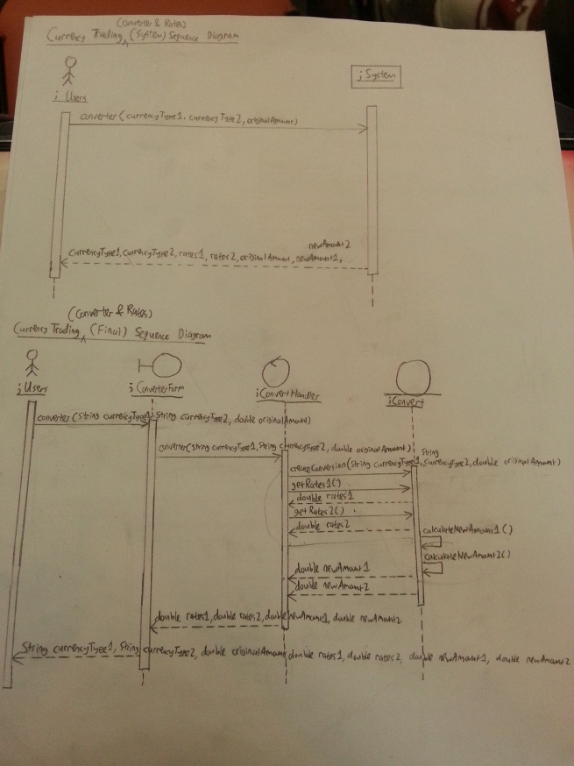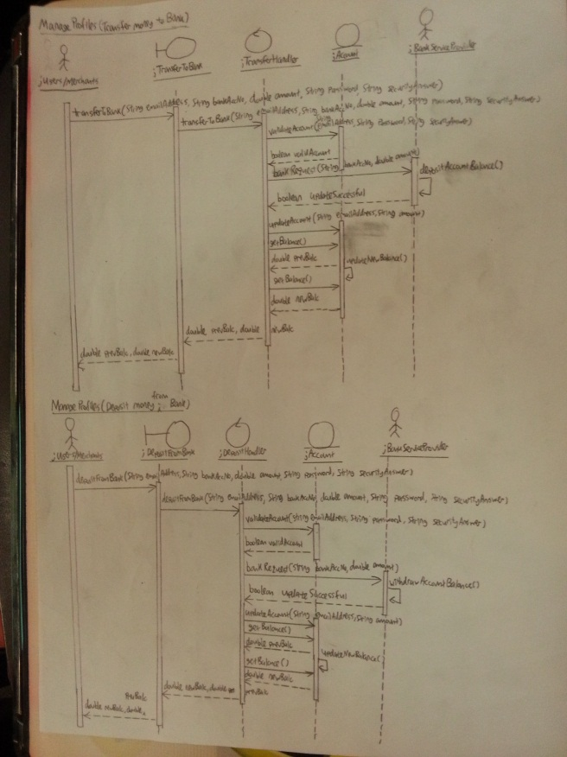

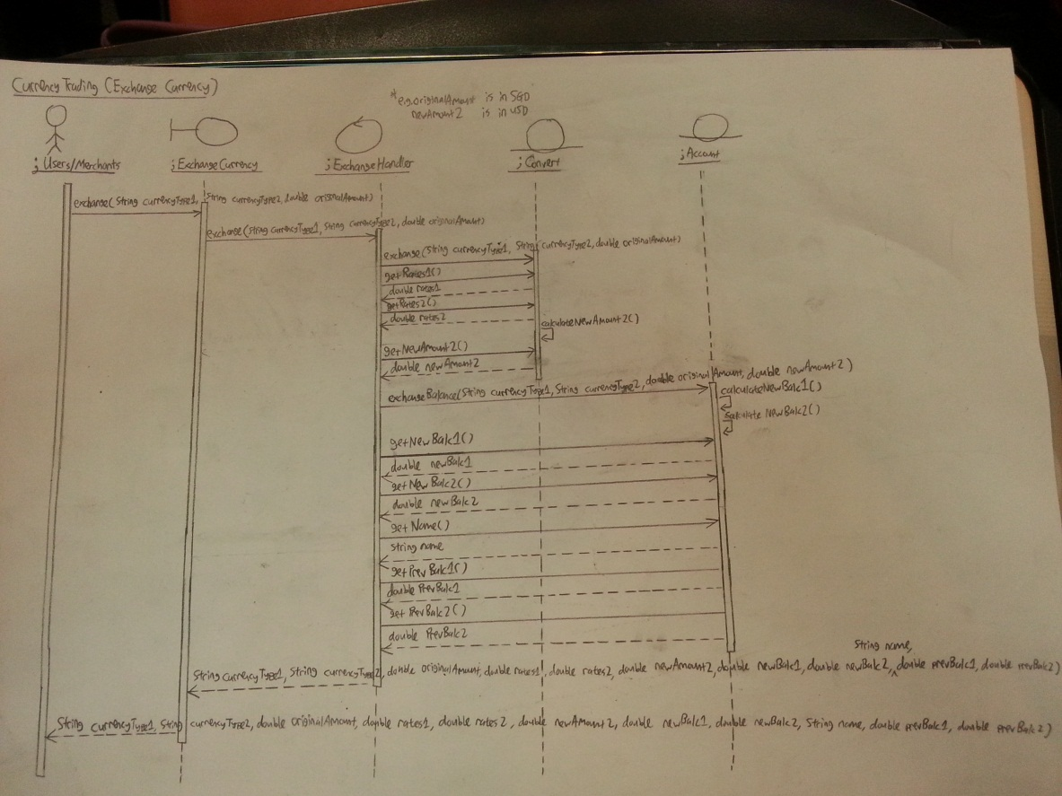

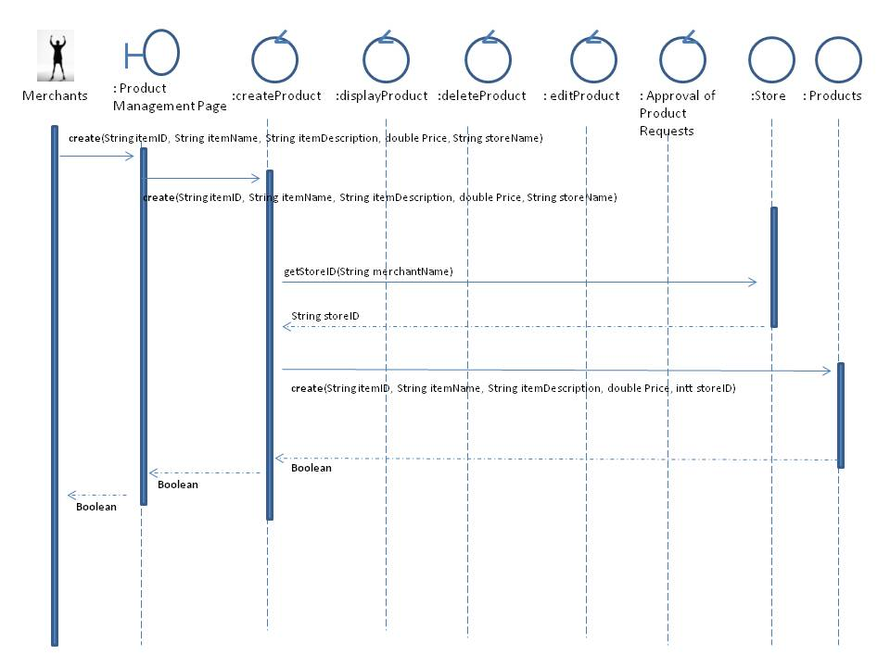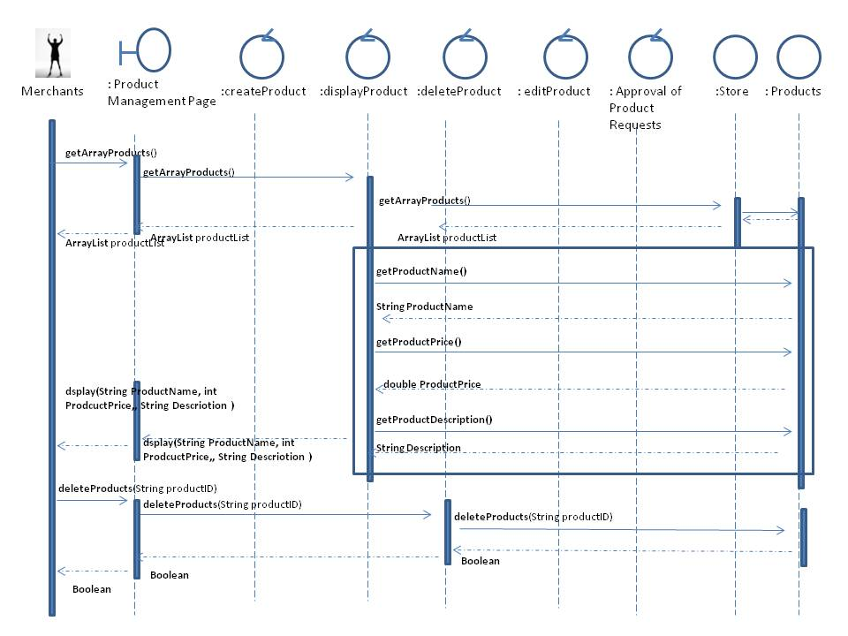

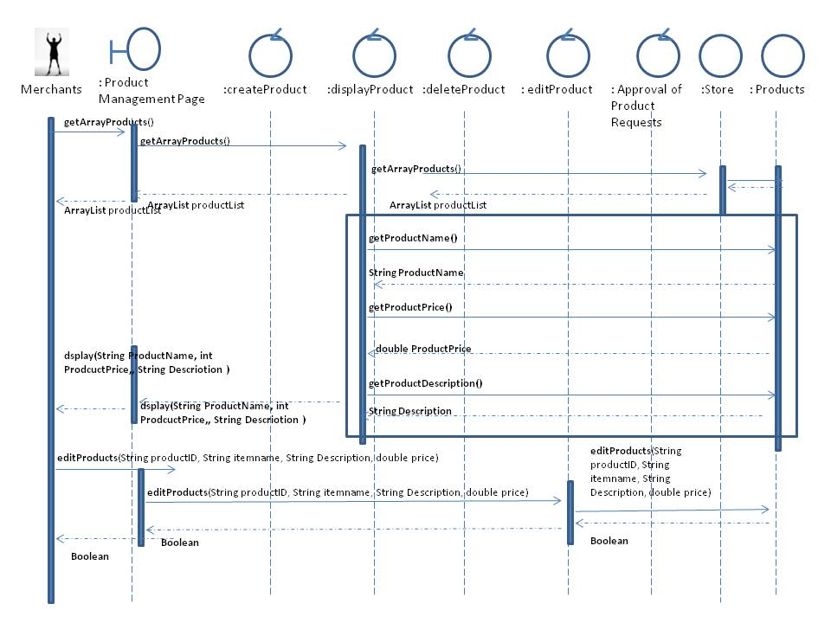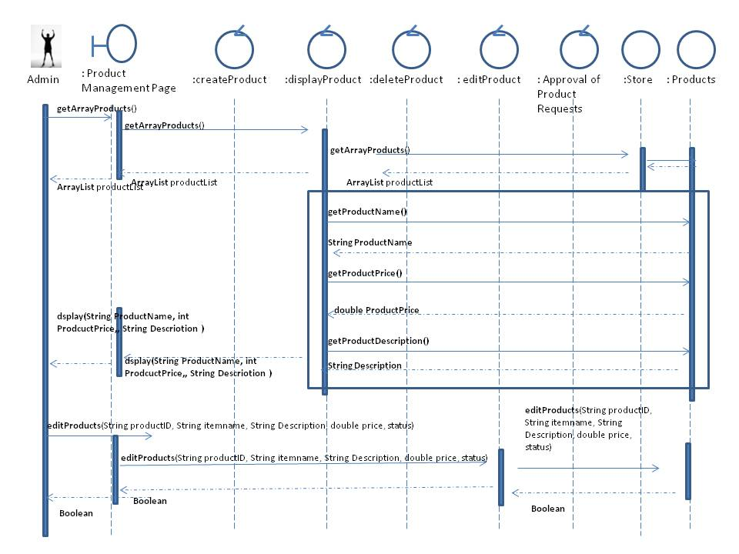

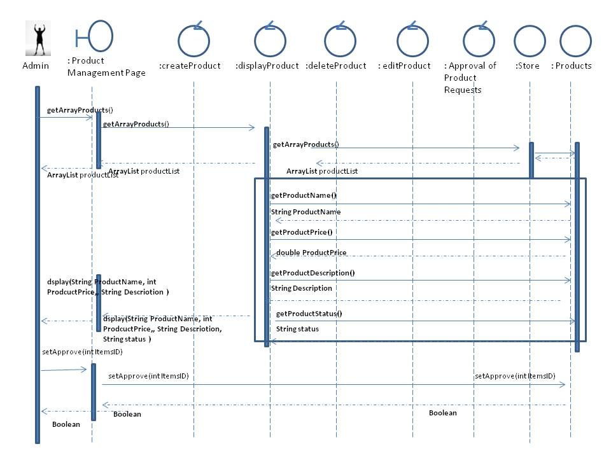

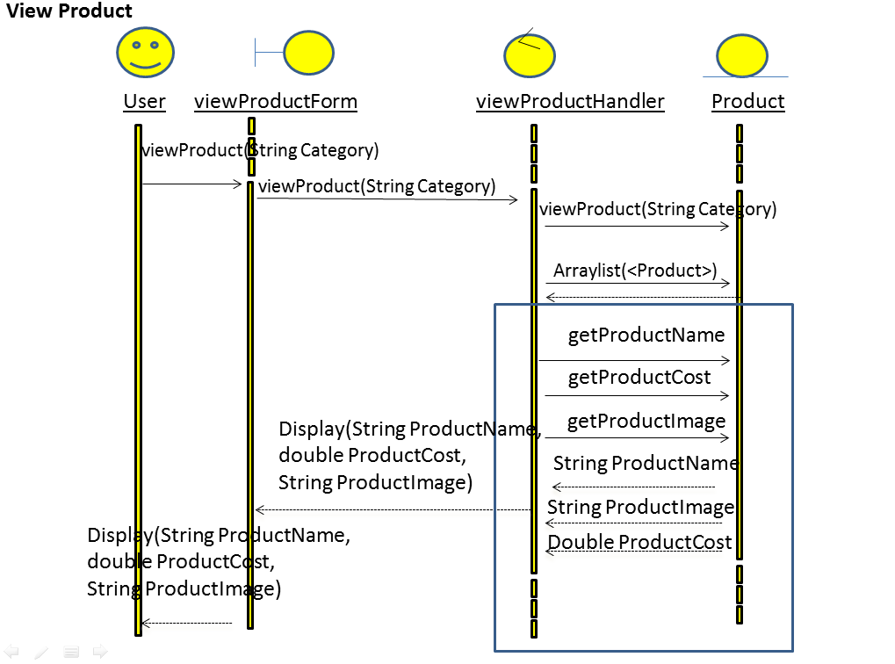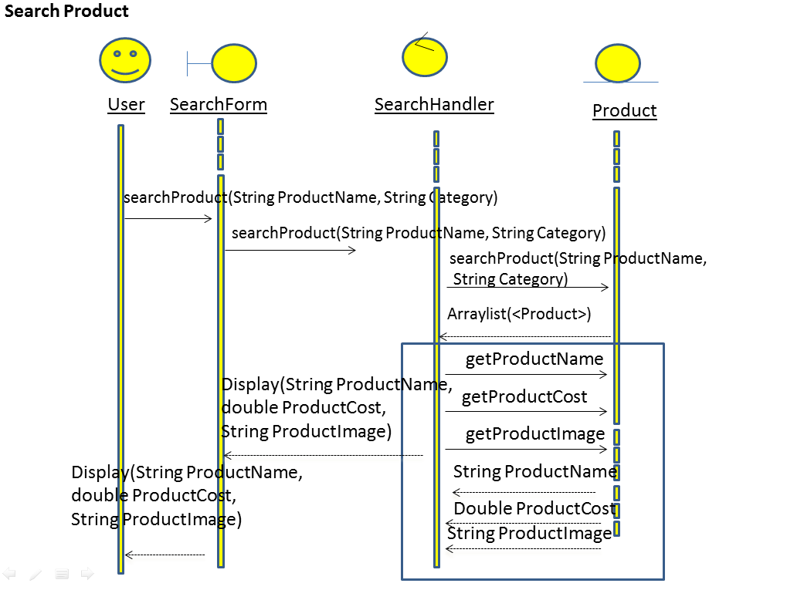

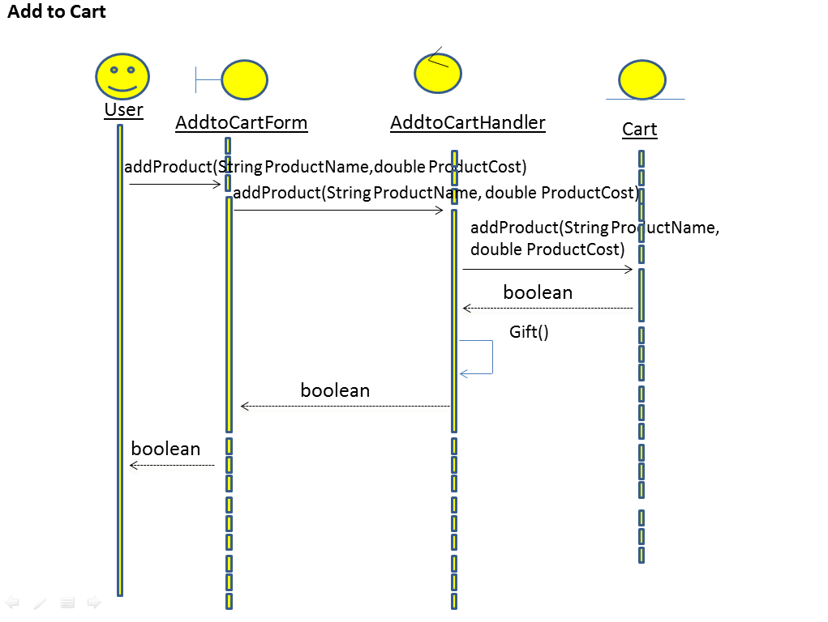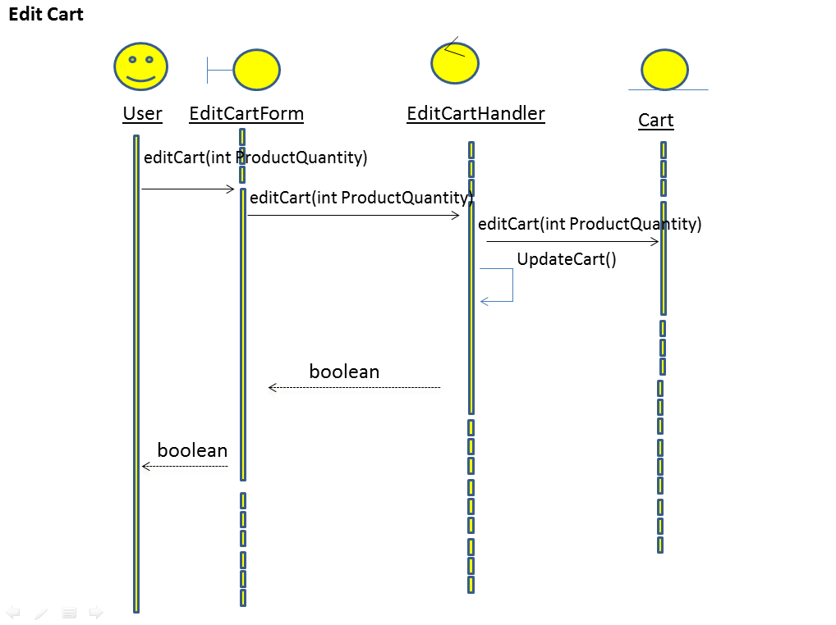.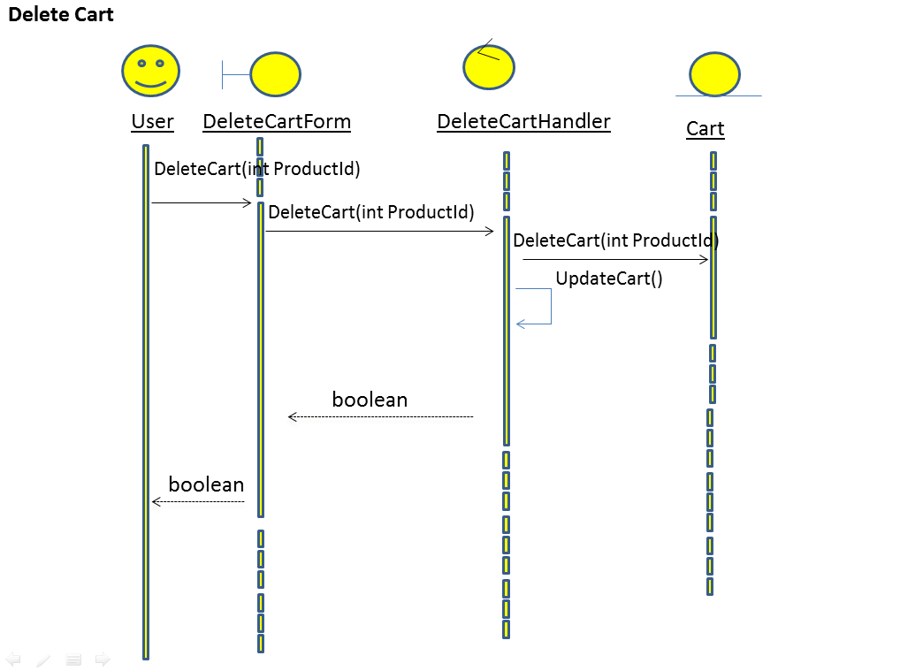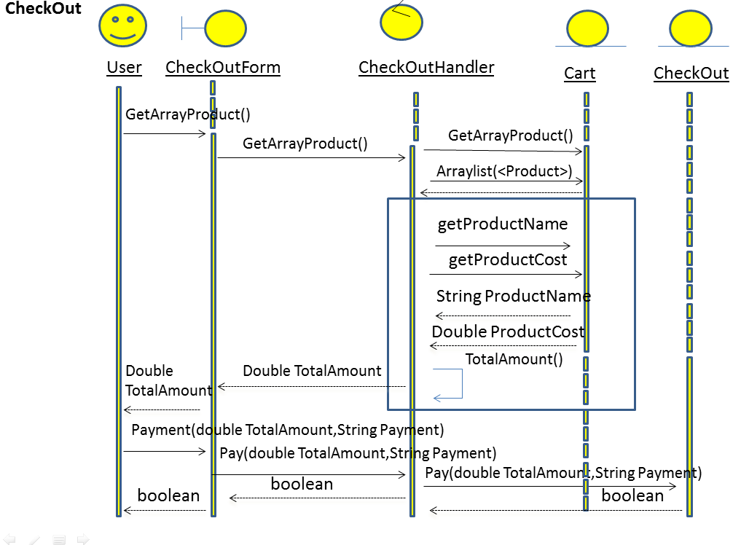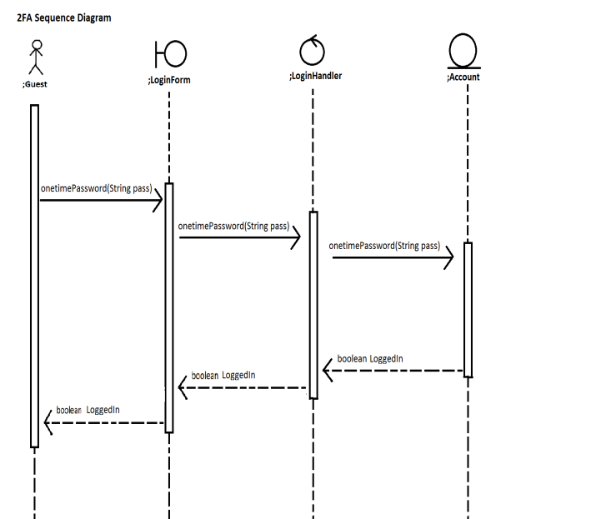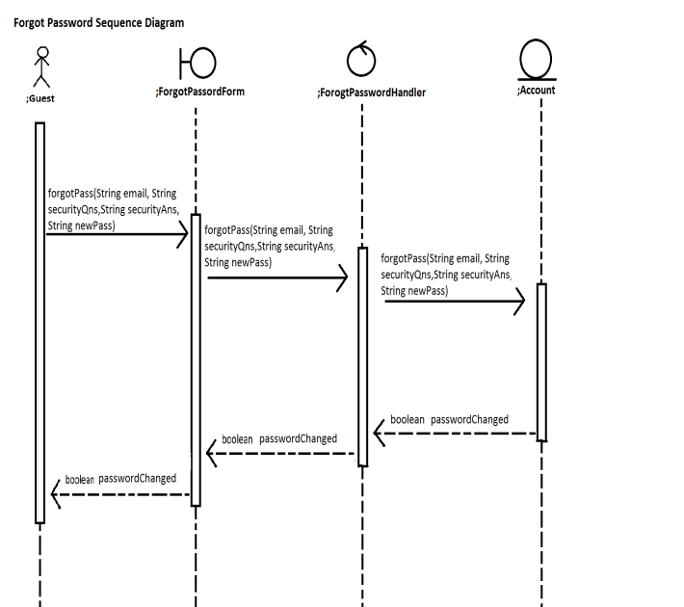

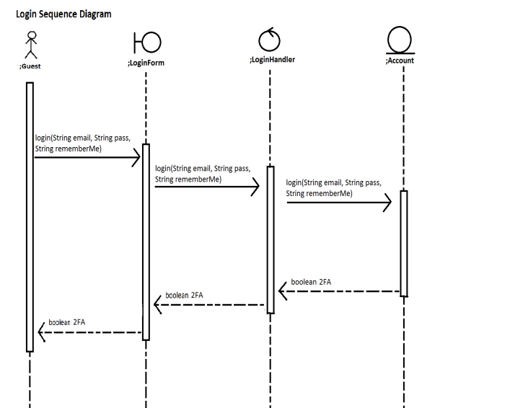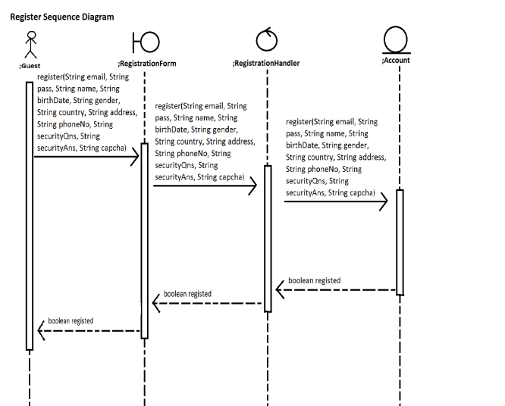

# Test Plan

**Alvin’s Test Plan**

**6.1 Test Setup**

1. Startup the web server and open the web page to the Login Page.
2. User will then login to their respective account
3. Upon successful login, user will be directed to the User Profile Page
4. From there, they can choose to Convert Currency or Transfer Money, it will then redirect he/she to the Currency Converter Page or Transfer Money Page respectively.

**6.2 Test Procedures**

1. **(Test Case 1 - 3)** When the user is in the Currency Converter Page, respective errors will occur if the user does not enter any input, or select the same currency types. If there are no errors occur, it will redirect the user to the Currency Exchange Page.
2. **(Test Case 4 - 5)** When the user is in the Currency Exchange Page, if user has insufficient funds in their respective currency balance, an error will occur. If the user has sufficient funds, there will be no error occurs and it will redirect the user to the Exchange Confirmation Page.
3. **(Test Case 6)** When the user is in the Exchange Confirmation Page, user will have to confirm the particulars and click confirm upon confirmation. It will then redirect the user to the User Profile Page.
4. **(Test Case 7 - 10)** When the user is in the Transfer Money Page, respective errors will occur if the user does not enter any input, the mentioned username was not found, or the user has insufficient funds in their respective currency balance. If there are no errors occur, it will redirect the user to the Transfer Confirmation Page.
5. **(Test Case 11)** When the user is in the Transfer Confirmation Page, user will have to confirm the particulars and click confirm upon confirmation. It will then redirect the user to the User Profile Page.

**6.3 Test Cases**

|  |  |  |  |  |  |
| --- | --- | --- | --- | --- | --- |
| **S/N** | **Test Case** | **Input** | **Expected Output** | **Actual Output** | **Pass / Fail** |
| 1. | **Currency Converter Page:** When user does not select currency types | **Attributes:** Amounts | **Error Message:** "*Please select a currency!"  **Redirect:** Currency Page | **Error Message:** "*Please select a currency!"  **Redirect:** Currency Page | **PASS** |
| 2. | **Currency Converter Page:** When user select the same currency types | **Attributes:** Amounts, CurrencyType1, CurrencyType2 | **Error Message:** "*Please select a different currency!”  **Redirect:** Currency Page | **Error Message:** "*Please select a different currency!”  **Redirect:** Currency Page | **PASS** |
| 3. | **Currency Converter Page:** When user select different currency types | **Attributes:** Amounts, CurrencyType1, CurrencyType2 | **Error Message:** null  **Redirect:** Convert Page | **Error Message:** null  **Redirect:** Convert Page | **PASS** |
| 4. | **Currency Exchange Page:** When user has **insufficient** funds in SGD/USD/EUR to exchange | **Attributes:** ExchangeType1, ExchangeType2 | **Error Message:** “*Insufficient Balance in SGD/USD/EUR”  **Redirect:** Convert Page | **Error Message:** “*Insufficient Balance in SGD/USD/EUR”  **Redirect:** Convert Page | **PASS** |
| 5. | **Currency Exchange Page:** When user has **sufficient** funds in SGD/USD/EUR to exchange | **Attributes:** ExchangeType1, ExchangeType2 | **Error Message:** null  **Redirect:** Exchange Confirmation Page | **Error Message:** null  **Redirect:** Exchange Confirmation Page | **PASS** |
| 6. | **Exchange Confirmation Page:** When user confirm to exchange amounts between 2 currency | **Attributes:** None | **Error Message:** null  **Redirect:** User Profile Page | **Error Message:** null  **Redirect:** User Profile Page | **PASS** |
| 7. | **Transfer Money Page:** When user does not input a value for username | **Attributes:** Amounts | **Error Message:** “*Please enter a username!”  **Redirect:** Transfer Money Page | **Error Message:** “*Please enter a username!”  **Redirect:** Transfer Money Page | **PASS** |
| 8. | **Transfer Money Page:** When the input username was not found | **Attributes:** Amounts, Username | **Error Message:** “*Username _____ not found!”  **Redirect:** Transfer Money Page | **Error Message:** “*Username _____ not found!”  **Redirect:** Transfer Money Page | **PASS** |
| 9. | **Transfer Money Page:** When user does not select a currency | **Attributes:** Amounts, Username | **Error Message:** “*Please select a currency!”  **Redirect:** Transfer Money Page | **Error Message:** “*Please select a currency!”  **Redirect:** Transfer Money Page | **PASS** |
| 10. | **Transfer Money Page:** When user has **insufficient** funds in SGD/USD/EUR to transfer | **Attributes:** Amounts, Username, CurrencyType | **Error Message:** “*Insufficient Balance in SGD/USD/EUR”  **Redirect:** Transfer Money Page | **Error Message:** “*Insufficient Balance in SGD/USD/EUR”  **Redirect:** Convert Page | **PASS** |
| 11. | **Transfer Confirmation Page:** When user confirm to transfer money to the username | **Attributes:** None | **Error Message:** null  **Redirect:** User Profile Page | **Error Message:** null  **Redirect:** User Profile Page | **PASS** |

**Amos’s Test Plan**

**6.1 Test Setup**

Buy a gift and get a voucher with a barcode and print out the barcode and use scanner to scan the barcode, Send a SMS for 2FA authentication to user's phone number.

**6.2 Test Procedures**

Open up scanner application and follow the test case from S/N 1 to 4, Sign up for a new account that require validation of the phone number.

**6.3 Test Cases**

|  |  |  |  |  |  |
| --- | --- | --- | --- | --- | --- |
| **S/N** | **Test Case** | **Input** | **Expected Output** | **Actual Output** | **Pass / Fail** |
| 1 | **Barcode:** Prints a unique bar code different from the rest | **Attributes:** Barcode | **File Output:** Print out the barcode and place it in the PDF file for user to download | **File Output:** Printed out the barcode and place it in the PDF file for user to download | **PASS** |
| 2 | **Barcode:** Scan the barcode to redeem the voucher | **Attributes:** Barcode | **Prompt Message:** This barcode has been redeemed. | **Prompt Message:** This barcode has been redeemed. | **PASS** |
| 3 | **Barcode:** Scan the same barcode twice, did it validate as valid or used? | **Attributes**  Barcode | **Error Message:** This barcode has been used, it's no long valid. | **Error Message:** This barcode has been used, it's no long valid. | **PASS** |
| 4 | **Barcode:** Error during scanner incorrect Barcode scanned | **Attributes**  Barcode | **Error Message:** This barcode is not found, an error has occurred. | **Error Message:** This barcode is not found, an error has occurred. | **PASS** |
| 5 | Can the SMS be sent? | **Attributes:** Phone Number | **Prompt Message:** SMS has been sent to the phone number | **Prompt Message:** SMS has been sent to the phone number | **PASS** |
| 6 | Not valid phone number is entered | **Attributes:** Phone Number | **Error Message:** This number cannot be sent, It's not valid | **Error Message** This number cannot be sent, It's not valid | **PASS** |
| 7 | Too many request sent at one time. | **Attributes:** Phone Number | **Prompt Message:** SMS has been sent to the phone number | **Prompt Message:** SMS has been sent to the phone number | **PASS** |
| 8 | Phone number that has been used | **Attributes:** Phone Number | **Error Message:** This number has been used. Can't be used to sign up multiple account | **Error Message:** This number has been used. Can't be used to sign up multiple account | **PASS** |

**Siew Yuet’s Test Plan**

**6.1 Test Setup**

Startup the web server and open the web page to the Index Page, this will display out the product that's available.

**6.2 Test Procedures**

1) On startup, it will redirect to the index page with the product added.

2) After login in, the merchant able to add, edit or remove product from the product management.

3) User added the product to the shopping cart before proceed to check out.

**6.3 Test Cases**

|  |  |  |  |  |  |
| --- | --- | --- | --- | --- | --- |
| **S/N** | **Test Case** | **Input** | **Expected Output** | **Actual Output** | **Pass / Fail** |
| 1 | **Login Page:** When user does not input any values for username & password | **Attributes:** None | **Error Message:** "*Please enter Username/Password!"  **Redirect:** Login Page | **Error Message:** "*Please enter Username/Password!"  **Redirect:** Login Page | **PASS** |
| 2 | **Product Page:** If there's any product on the product page | **Attributes:** None | There's product shown on the product page with the image, product name, price, quantity, and add to cart button | There's product shown on the product page with the product name and price | **PASS** |
| 3 | **Add to Cart:** Check if there's any product added to the shopping cart | **Attributes:** None | Display the product that's added to the cart | Display the product that's added to the cart | **PASS** |
| 4 | **Remove Cart Item:** Check that the product is remove when the button is click | **Attributes:** None | Able to remove cart item | Able to remove cart item | **PASS** |
| 5 | **Update Quantity:** Check that the product quantity is updated and the total price change | **Attributes:** Quantity | Able to update the quantity and the total cost of the product | Able to update the quantity and the total cost of the product | **PASS** |
| 6 | **Product Management:** Display only the merchant product | **Attributes:** None | Display out the merchant product with the product name, description, price, image | Display out the merchant product with the product name, price, image | **PASS** |
| 7 | **Add Item:** Able to add product from the product management | **Attributes:** Product name, price, description, upload image | Product added successfully and display out in the product page | Product added successfully and display out in the product page | **PASS** |
| 8 | **Edit Item:** Able to edit the item from the product management | **Attributes:** Product name, price, description, upload image | Product edited successfully and display out the updated item | Product edited successfully and display out the updated item | **PASS** |
| 9 | **Remove Item:** Able to remove the item from the product management | **Attributes:**  none | Product remove successfully and product is not displaying in the product page | Product remove successfully and product is not displaying in the product page | **PASS** |
| 10 | **Checkout**: Checkout through paypal | **Attributes:**  Product name, quantity, price | Display product to checkout added to the paypal page | Display product to checkout added to the paypal page | **PASS** |

**Wei Chen’s Test Plan**

**6.1 Test Setup**

-Startup the web server and open the web page to the Login Page.

**6.2 Test Procedures**

1) (Test Case 1) At the Login Page, click on the submit button with entering any fields.

2) (Test Case 2) At the Login Page, fill up all fields while one of field having the wrong value. Click submit button.

3) (Test Case 3) At the Login Page, fill up all fields with their correct value. Click submit button.

4) (Test Case 4) From the Login Page, click on the link to Register Page. Then on the Register Page, click on the submit button with entering any fields.

5) (Test Case 5) At the Register Page, fill up all fields while one of field having the wrong value. Click submit button.

6) (Test Case 6) At the Register Page, fill up all fields with their correct value. Click submit button.

7) (Test Case 7) At the Login Page, click on the forget password link. On the Forgot Password Page, fill up all the fields and click the retrieve password button.

**6.3 Test Cases**

|  |  |  |  |  |  |
| --- | --- | --- | --- | --- | --- |
| **S/N** | **Test Case** | **Input** | **Expected Output** | **Actual Output** | **Pass / Fail** |
| 1. | **Login Page:** When user does not input any values for username & password | **Attributes:** None | **Error Message:** "*Please enter Username/Password!"  **Redirect:** Login Page | **Error Message:** "*Please enter Username/Password!"  **Redirect:** Login Page | **PASS** |
| 2. | **Login Page:** When user enter the **wrong** values for username or password | **Attributes:** Username, Password | **Error Message:** "*Wrong Username/Password!"  **Redirect:** Login Page | **Error Message:** "*Wrong Username/Password!"  **Redirect:** Login Page | **PASS** |
| 3. | **Login Page:** When user enter the **correct** values for username or password | **Attributes:** Username, Password | **Error Message:** null  **Redirect:** User Profile Page | **Error Message:** null  **Redirect:** Profile Page | **PASS** |
| 4. | **Register Page:** When user does not input any values for  firstName, lastName, email, password, gender, birthDate, country, phoneNo, userName | **Attributes:** firstName, lastName, email, password, gender, birthDate, country, phoneNo, userName | **Error Message**: "*Please enter your Username (etc.)!"  Redirect: Register Page | **Error Message**: "*Please enter your Username (etc.)!"  Redirect: Register Page | **PASS** |
| 5. | **Register Page:** When user enter the **wrong** values for  firstName, lastName, email, password, gender, birthDate, country, phoneNo, userName | **Attributes:** firstName, lastName, email, password, gender, birthDate, country, phoneNo, userName | **Error Message**: "*Invalid Username (etc.)!"  Redirect: Register Page | **Error Message**: "*Invalid Username (etc.)!"  Redirect: Register Page | **PASS** |
| 6. | **Register Page:** When user enter the **correct** values for  firstName, lastName, email, password, gender, birthDate, country, phoneNo, userName | **Attributes:** firstName, lastName, email, password, gender, birthDate, country, phoneNo, userName | **Error Message:** null  Redirect: AccountCreated Page | **Error Message:** null  Redirect: AccountCreated Page | **PASS** |
| 7. | **Forgot Password Page:**  When user enter the values for userName and email | **Attributes:**  userName and email | New password is randomly generated and sent to the user’s email. | No new password generated. The actual password of the user is being sent to the user’s email. | **FAIL** |

**Jian Hao’s Test Plan**

**6.1 Test Setup**

1) Startup the web server and open the web page to the Account Manager.

2) Check to see if test case 1 can be done.

**6.2 Test Procedures**

1) (Test Case 1) On startup, look at the table of the AccountManager.jsp page and see if all the accounts in the database are listed out.

2) (Test Case 2) In the filter section below the tables. Enter in the appropriate fields and click the filter button.

3) (Test Case 3) Go to the Create Admin.jsp page. Enter in the account details and press the create button.

**6.3 Test Cases**

|  |  |  |  |  |  |
| --- | --- | --- | --- | --- | --- |
| **S/N** | **Test Case** | **Input** | **Expected Output** | **Actual Output** | **Pass / Fail** |
| 1 | See if the Account details can be loaded into the system. | None | All the user account details |  |  |
| 2 | Check if the system can filter or search for accounts in the system successfully. | Account attributes, first name, last name, first address, second address, city, phone, post code and user group | Shows all user accounts that match the condition. |  |  |
| 3 | Create a User account. | Account attributes, first name, last name, first address, second address, city, phone, post code and user group | Creates a user account based on the attributes. |  |  |

# Conclusion

## Summary of Completed Tasks

## Summary of Future Enhancements

## Lessons Learnt

# Appendices

## Website

http://www.google.com

http://en.wikipedia.org

## Books